 | Be present  Complete the absence form on the website if you can’t attend  Have your full name visible  Turn your camera on  Be in an appropriate setting  Be ready to learn  Participate  Clothes are not optional!
Chatham House rules apply  We hope you will feel able to chat freely and respect the confidentiality of anything discussed during the session. | 
 | Be mindful not to interrupt each other  It’s more difficult in remote sessions so take turns.  Raise your real hand, your virtual hand or write in the chat.
Get involved in breakout rooms  Take it in turns to volunteer to chair the room and be spokesperson for the room back in the main group. | 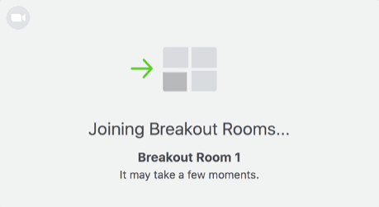
 | Message the group with an apology if you need to leave to take a phone call, answer the door for a delivery, stop the kids killing each other, let the cat out etc.
Use your phone or computer only as a learning resource  It is not possible to have your mind completely on two things at once….even if you think you are an expert at multi-tasking! | 
 | Fill out the feedback form  Help improve and shape the programme  Mark your attendance at the session
Durham Tees Valley GP Training Programme
Remote Teaching Etiquette 2020

