Be present
Complete the absence form on the website if you can’t attend
Have your full name visible
Turn your camera on
Be in an appropriate setting
Be ready to learn
Participate
Clothes are not optional!

Chatham House rules apply
We hope you will feel able to chat freely and respect the confidentiality of anything discussed during the session.

Be mindful not to interrupt each other
It’s more difficult in remote sessions so take turns.
Raise your real hand, your virtual hand or write in the chat.

Get involved in breakout rooms  Take it in turns to volunteer to chair the room and be spokesperson for the room back in the main group. | 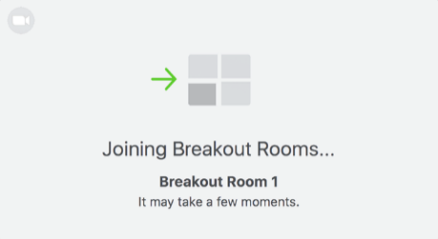
 | Message the group with an apology if you need to leave to take a phone call, answer the door for a delivery, stop the kids killing each other, let the cat out etc.
Use your phone or computer only as a learning resource
It is not possible to have your mind completely on two things at once….even if you think you are an expert at multi-tasking!
Fill out the feedback form
Help improve and shape the programme
Mark your attendance at the session
Durham Tees Valley GP Training Programme
Remote Teaching Etiquette 2020

